

Proposal
CENE 476: Capstone Prep

To: Dr. Bridget Bero
From: Synergy Engineering
Abdulaziz Alajmi, Yang Ding, Yijie Gao, Phoo Myat Sandy Maung



Date: May 4, 2016

Table of Contents
1.0 Project Understanding 4
1.1 Project Purpose 4
1.2 Project Background 4
1.3 Technical Considerations 10
1.4 Potential Challenges 10
1.5 Stakeholders 10
2.0 Scope of Services 11
2.1 Task 1.0 Site Selection 11
2.2 Task 2.0 Surveying 11
2.3 Task 3.0 Design Documents Review 11
2.4 Task 4.0 Structural Design 12
2.5 Task 5.0 Engineer’s Estimate of Construction Cost Estimate 13
2.6 Task 6.0 Project Management 13
2.6 Exclusions 14
3.0 Project Schedule 15
4.0 Staffing and Cost of Engineering Services 16
4.1 Staff Plan 16
4.2 Cost Estimate for Engineering Services 17
5.0 References 21

Project Understanding

1.1 Project Purpose
The primary purpose of the project is to choose a site location for an expansion of the existing NAU International Pavilion and to design an additional building. The expansion is estimated to be 15,000 square feet. The space usage is listed below:
- 5000 square feet for classrooms
- 2000 square feet for offices
- 2500 square feet for student community space
- 3000 square feet for student study areas
- 400 square feet for the mechanical and electrical room
- 2000 square feet for miscellaneous use
Some of the building space may be dual purpose and allow for a reduced area.

1.2 Project Background
The existing NAU International Pavilion is located on central campus of Northern Arizona University (NAU). It is 10,000 square feet and it features student lounge space, a game area, and event space. The popularity of the existing facility has created a need for substantially more space. Therefore, Meyer Borgman Johnson Engineering requested Synergy Engineering to propose an expansion plan for an additional building at the vicinity of the existing building. The new location of the expansion would be either north, south, or west of the existing building. The east side of the building could be an option if the expansion spread over the pedestrian walkway. Figure 1.1 shows the location of International Pavilion in Flagstaff. Figure 1.2 shows the location of the International Pavilion and the surrounding buildings. A detention basin is located directly north of the existing building. A filtration tank below the detention basin to the north has a 10,000-gallon capacity. Figure 1.3 shows a north side view of the existing building. The detention basin located in north side of the building can be seen in the site plan of the building, which is shown in Figure 1.4.
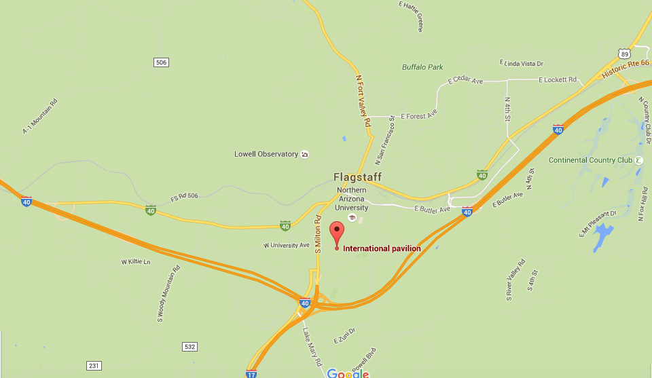
Figure 1.1 Location of International Pavilion building on Flagstaff map [1]
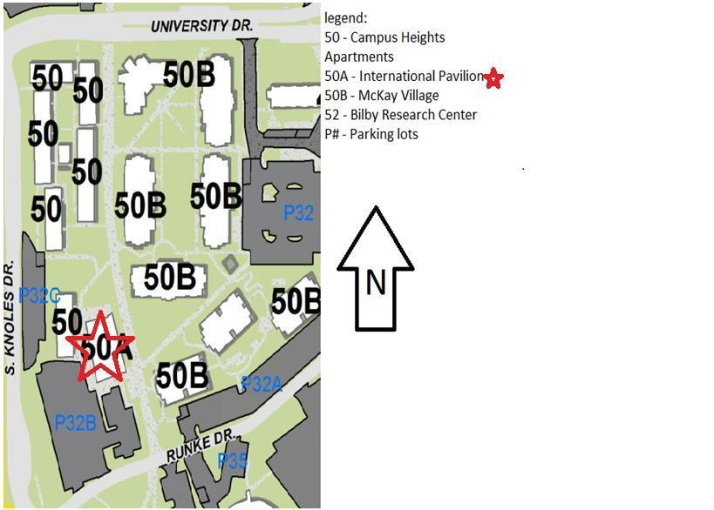
Figure 1.2 Location of International Pavilion building and the surrounding buildings [2]
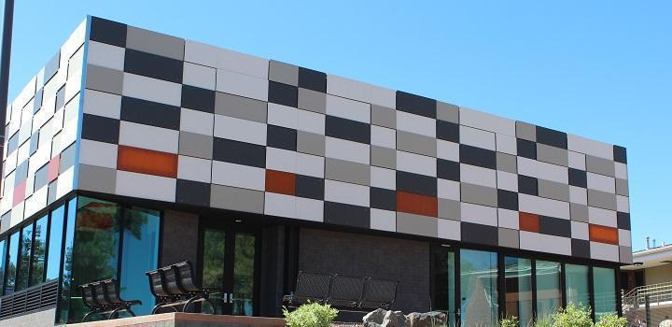
Figure 1.3 North elevation view of the building (looking south)
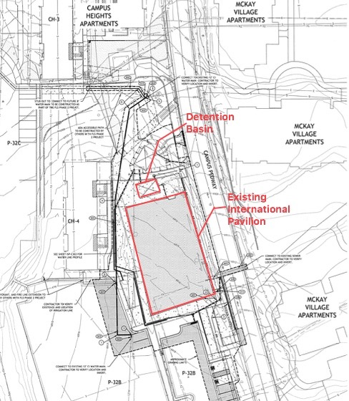Figure 1.4 Site plan of the building [3]
1.2.1 Geotechnical
The typical native soil is medium dense silty sand with a depth from ground level 3 ft to a 5.5ft in the south side and a 6.5’ of depth on the north side. However, due to a previous pavement cover (parking lot) there was a fill from ground level until 2.5ft of medium dense silty sand on both of the sides and 2.5 ft of medium dense well graded sand beneath the silty sand on the north side. Moreover, according to Speedie soil report [4], the weathered limestone bedrock that is beneath the native silty sand layer as shown in figure 1.5 can withstand a 3,500 psf which is the proposed building loads. Also the bedrock have the ability to increase the capacity by third of the dead loads if needed due to seismic load and any additional lateral loads. Figure 1.5 illustrate the profile of the soil before constructing the building and when the building finished the foundation was a shallow and settled on the weathered limestone layer. 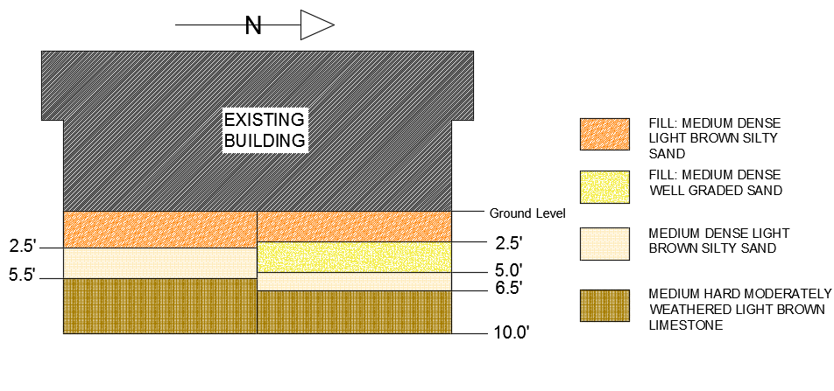
Figure 1.5 Soil profile for International Pavilion Building
1.2.2 Existing Building Layout
The International Pavilion building holds 10,000 square feet of classes and offices. The specific locations of each room for the first floor and the second floor are shown in Figures 1.5 and 1.6 below. One of the spaces that is used effectively is the flexible classrooms area on the first floor. Moveable walls are used to split or connect the space.
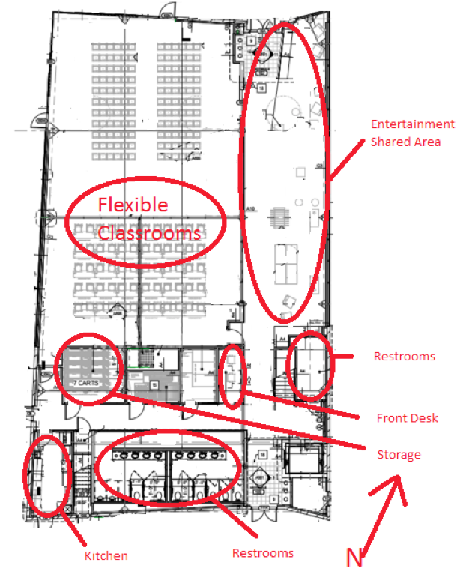
Figure 1.6 International Pavilion first floor existing space distribution [3]

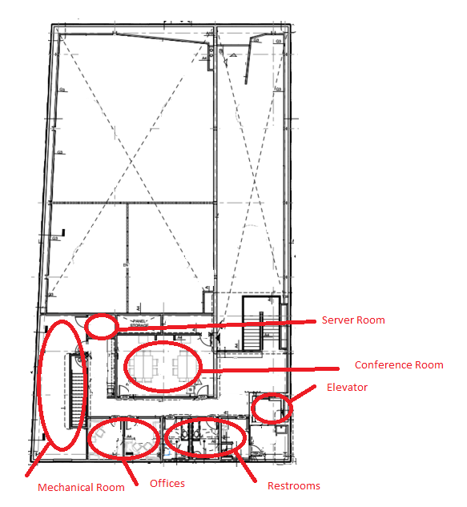
Figure 1.7International Pavilion second floor existing space distribution [3]
The building is certified as LEED Platinum according to the USGBC rating system for green buildings. To obtain this rating, the building achieved a certain number of “green characteristics”, or sustainable design points. Some of the green characteristics include natural ventilation and natural sunlight. The building uses natural ventilation for the open spaces on the first floor and air conditioning units for the offices on the second floor. Natural sunlight that comes through sealed skylights openings on the roof provides daytime lighting. Solar panels on the roof produce 100% enough energy to offer all building consumption. of the building’s energy needs and the solar power actually goes to the building. The building has its own radiant heat floors system for climate control during the winter months.

1.3 Technical Considerations
There are three technical aspects to consider for this project: geotechnical analysis, site analysis, and structural analysis. The geotechnical analysis will investigate the soil conditions, design parameters for proposed foundations, and earth retention structures. The civil analysis will address the implications of each proposed location of building to determine the ideal location of the proposed structure. The structural analysis will include the analysis of loading for the beams, columns, and walls, designing the foundation plan, framing plans, and site retaining wall designs. The building shall be designed to meet the International Building Code 2012 adopted by NAU.

In addition, an important functional consideration will be how to connect the new structure with the existing one. The site work may include relocating the current parking lot if the additional building is built on the south, east, or west side of the existing building or repositioning the detention basin if the north side of the existing building is chosen.

1.4 Potential Challenges
The challenge of this project is to aesthetically and functionally design an additional building given the site constraints. Additionally, some site options will take up the existing parking lot, which may need to be relocated.

1.5 Stakeholders
The stakeholders of this project include Meyer Borgman Johnson Engineering, the Arizona Board of Regents, NAU, residents near the expansion, Dr. Robin Tuchscherer, Professor Kai Kaoni, and NAU students.

Scope of Services
This section of the proposal details the tasks required to complete the project. These tasks will include but are not limited to structural design, structural analysis, civil analysis, and geotechnical analysis.

2.1 Task 1.0 Site Selection
Four potential locations will be considered based on functional concerns, site drainage, site utilities, potential relocation of the parking lot, relocation of the detention basin, and connection to the existing building. The aesthetic design in order to complement the existing building will also be considered. Four feasible options will be considered. The final decision will be determined by a decision matrix to analyze the above considerations.

2.2 Task 2.0 Surveying
By surveying the selected site location, the team will determine the area of footprint, finished floor elevation, quantity of cut or fill, and the surrounding facilities needed to move or relocate.

2.3 Task 3.0 Design Documents Review
Speedie & Associates prepared the geotechnical reports for the area around International Pavilion in 2013 [2,3]. They did the soil borings and made recommendations for the International Pavilion. According to the soil reports at the vicinity of the expansion site, bearing capacity, the depth to the bedrock, the depth to the water table, and the saturation level of the soil for the additional building site have been determined. This data will be reviewed and foundation recommendations for the new building will be made based upon Speedie’s soil report.
Deliverable: A one page summary will be provided after the soil reports are reviewed.
The NAU Technical Standards, the City of Flagstaff Engineering Standards, and the International Building Code (IBC) 2012 codes will be referenced for the new building. Time will be allotted to examine the structural codes in order to ensure the new design matches the code. These codes will serve as guidelines for the project. The NAU Technical Standards will help the design to fit the constraints of NAU. The City of Flagstaff Engineering Standards will help tie in any design element with the city of Flagstaff standards. The IBC 2012 will help finalize the design to ensure it meets all design safety requirements.
Deliverable: The information important for this design will be summarized into a one-page report and abided by the team throughout the design process.

2.4 Task 4.0 Structural Design
This task consists of the structural drawings of the building layout, foundation plan, framing plans and typical details and earth retention structures. The structural drawing will be the most comprehensive part for the final design and the team will spend most of the time on this section.
2.4.1 Task 4.1 Building Layout Options
The number of stories, the general space layout, how the two buildings will be connected will be determined in this task.
2.4.2 Task 4.2 Foundation Plan and Details
The foundation plan of the building will be designed according to the soil condition and anticipated design loads. The plan will be completed using AutoCAD software. The details will also be selected using the software.
Deliverable: It includes a 50% design, 95% drawing and a final design.
2.4.3 Task 4.3 Framing Plan and Details
The framing plans for each story of the building and the roof will be generated using RISA 3D software [5]. The detailed drawings of beams, columns, floor slabs, basic connections, and shear walls will be analyzed using RISA 3D software for the final design. It includes a 50% design, 95% drawing and a final design. The structural design will include a gravity system design and a lateral system design. The gravity system design encompasses live load and dead load calculations for floors, roofs, columns, and walls. The lateral system design includes the Main Wind Force Resisting System (MWFRS) design and seismic resisting system design.
Deliverable: It includes a 50% design, 95% design and a final design.

2.4.4 Task 4.4 Earth Retention Structures
The earth retention structures to be considered by the team will be retaining walls. The geotechnical report will be used to provide information for designing the retaining walls. Since the size of the retaining walls depends on the amount of excavation done, hand calculations will be used to size retaining walls.
Deliverable: Retaining walls will be shown on the foundation plan. Details will be provided with the 50%, 95%, and final design documents.

2.5 Task 5.0 Engineer’s Estimate of Construction Cost Estimate
An estimate of construction cost of the project will be estimated so that a project budget can be established. Items included will be geotechnical and site costs and building costs that are within the scope of the design.
Deliverable: 50%, 95%, and 100% cost estimate will be provided to the client.

2.6 Task 6.0 Project Management
This task consists of team management, client management, and deliverables. The details of each tasks are explained below.
2.6.1 Task 6.1 Team Management
The team will have a technical advisors meeting and an individual team meeting each week. There will be additional meetings if needed. The meeting agenda and email reminder will be send out by Yijie at least one day before the meeting. The meeting minutes will be taken by Phoo. Any decision to be made will be discussed in the team with suggestions from technical advisors.
2.6.2 Task 6.2 Client Management
The team will maintain the client contact through emails and make appointments to talk with the client when there is important decision to be made or when the team needs verifications.

2.6.3 Task 6.3 Final Report, Presentation and website
- 50% Design Report
The 50% design report will be provided when the project is approximately 50% complete and will include building layout options, foundation plan and details, framing plans and details, the earth retention structure details and a 50% cost estimates. The report will be provided to the technical advisors and client for changes and suggestions.

- Final Design Report
The final design report will include all drawings and detailed information of the new additional building and the 100% cost estimates for the project.

- Final Presentation
The final design and solution with main categories and crucial details will be illustrated during the final presentation. Additionally, the scope of the project and how it relates to the client request will be explained in the final presentation.

- Website
A website will be built to provide all detailed information of the project. The link to the website will be on the NAU College of Engineering, Forestry, and Natural Sciences (CEFNS) capstone webpage and can be viewed by all customers.

2.6 Exclusions
This project is limited to siting, geotechnical considerations, and structural steel design of the building. The following exclusions to this project are noted. Furthermore, any items that are not listed in the scope of services are also exclusions.

- Mechanical, Electrical and Plumbing (MEP)
The weights of the mechanical, electrical and plumbing systems supported by the structure will be considered in the design. However, the MEP drawings and specifications will not be provided.
- Architectural Design
Even though the impact of architectural design will be considered as part of the structural design and construction costs, the architectural drawings and specifications will not be provided. NAU Professor of Practice of Architecture will be consulted for any critical architectural considerations need to complete the site or structural designs.
- Utilities
When designing the foundation design for the new addition building, the impact of the utilities’ locations will be considered but the exact locations will not be shown on the final drawings.
- Permitting
The City of Flagstaff requires several permits when constructing new buildings in their area. All of the permits will have to be considered before the construction phase begins. Permitting requirements will be done by others.
- Americans with Disabilities Act (ADA)
Although the ADA standards must be followed when designing a building, these standards will not be incorporated into the structural design. However, the building design will include space for one elevator and one stair.

Project Schedule
The project schedule with critical tasks, milestones and durations is shown in Figure 3.1. All the tasks will be completed in December 12, 2016. Site selection is the first task, which begins on August 29th and ends on September 5th. Surveying and design documents review, which are the second and third tasks, begin on September 6th and end on September 9th. Then, the team will focus on the structural designs from September 16th to November 25th. The structural design includes building layouts, foundation plan and details, framing plan and details, and earth retention structure with details. Building layout starts on September 16th and ends on September 23rd. Foundation plans and details starts on September 26th and end on October 12th. Framing plans and details starts on October 13th and ends on November 15th. Finally, earth retention structural plans starts on November 16th and ends at November 25th. During the period of structural design, construction cost estimates will also be conducted from September 20th to November 28th. It is noted that the project management starts from the beginning and ends at the end of the semester, which includes team management, client management and deliverables.
The critical path of the project consists of all the tasks except the construction cost estimate task. The Gantt chart showing the entire project schedule is shown in Figure 3.1. Gantt Chart.jpg
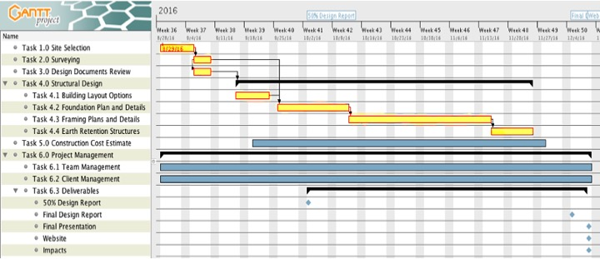
Figure 3.1 Gantt Chart

Staffing and Cost of Engineering Services

4.1 Staff Plan
4.1.1 Project Manager (PM):
The project manager is responsible for covering the project management tasks (e.g., keeping team members on schedule and updated on project progression), reviewing the work, regulations, and creating and editing design papers and presentations.

4.1.2 Project Engineer (PE):
This project engineer is responsible for designing the elements of each task of the project by using the RISA 3D software and helping other engineers with questions and problems.

4.1.3 Project Engineer (PE):
This project engineer is responsible for the structural analysis, the engineering notebook and data collections. Structural Analyst must have a good understanding of structural members and building designs.

4.1.4 AutoCAD Design Manager (CADDM):
The AutoCAD design engineer is responsible for inputting and managing data in AutoCAD 2015, Microsoft Word and excel. The AutoCAD design manager will have a good understanding and experience with using CAD drawings.

4.2 Cost Estimate for Engineering Services
4.2.1 Person-Hour Breakdown
The overall project has been separated into 8 general tasks. The working hours for the PM, PEs and CADDM are shown in Table 4.1.
Table 4.1: Hourly Breakdown for each positions
Task | PM Hours | PE  Hours | CADDM Hours
Task 1.0 Site Selection | 16 | 24 | 10
Task 2.0 Geotechnical Evaluation | 10 | 24 | 10
Task 3.0 Codes and Design Standards | 12 | 24 | 12
Task 4.0 Structural Design | 124 | 240 | 128
Task 5.0 Construction Cost Estimate | 10 | 28 | 10
Subtotal | 172 | 340 | 170
Total (hours) | 682

The total hours for the project manager, project engineers, and AutoCAD design manager are 172 hrs, 340 hrs, and 170 hrs respectively.

4.2.2 Billing Rate
The base pay rates for the PM, PEs and CADDM are shown in Table 4.2. These rates are the amount each position will be paid per hour. The actual pay is the amount that a company pay a personnel along with benefits. The billing rate shown in Table 4.2 includes benefits, overhead costs, and the amount of profit the company will make. The billing rate for the PM, PE and CADDM is $195, $103 and $80 respectively.

Table 4.2: Billing Rate
Classification | Base Pay $/hr | Benefits % of Base Pay | Actual Pay $/hr | OH % of Base Pay | Actual Pay + OH | Profit, % of Actual Pay | Billing Rate $/hr
PM | 90 | 40 | 126 | 60 | 180 | 8 | 195
PE | 60 | 30 | 78 | 30 | 96 | 8 | 103
CADDM | 35 | 70 | 59.5 | 40 | 73.5 | 8 | 80
PE | 60 | 30 | 78 | 30 | 96 | 8 | 103

4.2.3 Total Project Cost
The total project cost includes personnel and travel for the project. The personnel expenses cover the costs for each position. The travel expenses cover a round trip travel cost to Phoenix for a client meeting. As the team will survey the selected site location, surveying equipment rental cost is added to the project cost. The purchased codes and standards covers the cost for the necessary codes and standards to follow in designing. The total project costs is $83,105 as shown in Table 4.3.

Table 4.3: Total Project Cost
1.0 Personnel | Classification | Hours | Rate, $/hr | Cost
 | PM | 172 | 195 | $33,540
 | PE | 340 | 103 | $35,020
 | CADDM | 170 | 80 | $13,600
 | Total Personal |  |  | $82,160
2.0 Surveying Equipment Rentals |  | 10 | 20 | $200
3.0 Travel |  | Miles | Rate, $/mile
 | 1 meeting at Phoenix | 288 | 0.50 | $144
4.0 Code and Standards Purchase |  |  |  | $600
5.0 Total |  |  |  | $83,105

5.0 References
[1] "Google Maps", Google Maps, 2016. [Online]. Available: https://www.google.com/maps?ion=1&espv=2&q=northern+arizona+university&bav=on.2,or.r_cp.&biw=1242&bih=585&dpr=1.1&um=1&ie=UTF-8&sa=X&ved=0ahUKEwinh9-Y4_vLAhVX6GMKHVEjDAsQ_AUIBygC.
[2] Northern Arizona University, Interactive Campus Map. 2016.
[3] Peak Engineering Inc., "NAU International Student Pavilion", Phoenix, 2015.
[4] SPEEDIE and Associates, "Report on Geotechnical Investigation", Phoenix, 2014.
[5] RISA 3D. RISA Technologies, 2016.

